(2) Steps to experiment on web application
Ans 2:
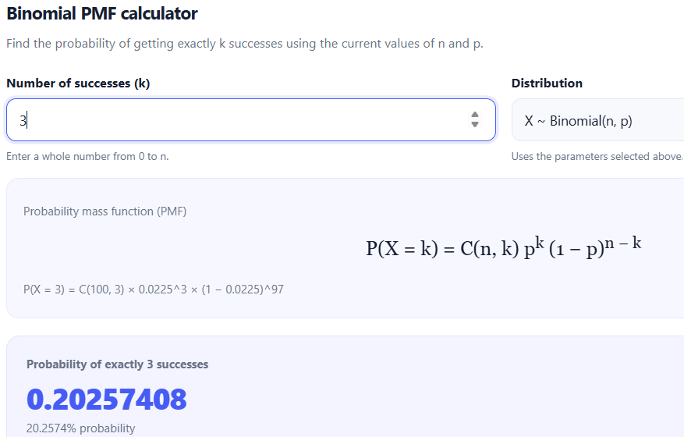
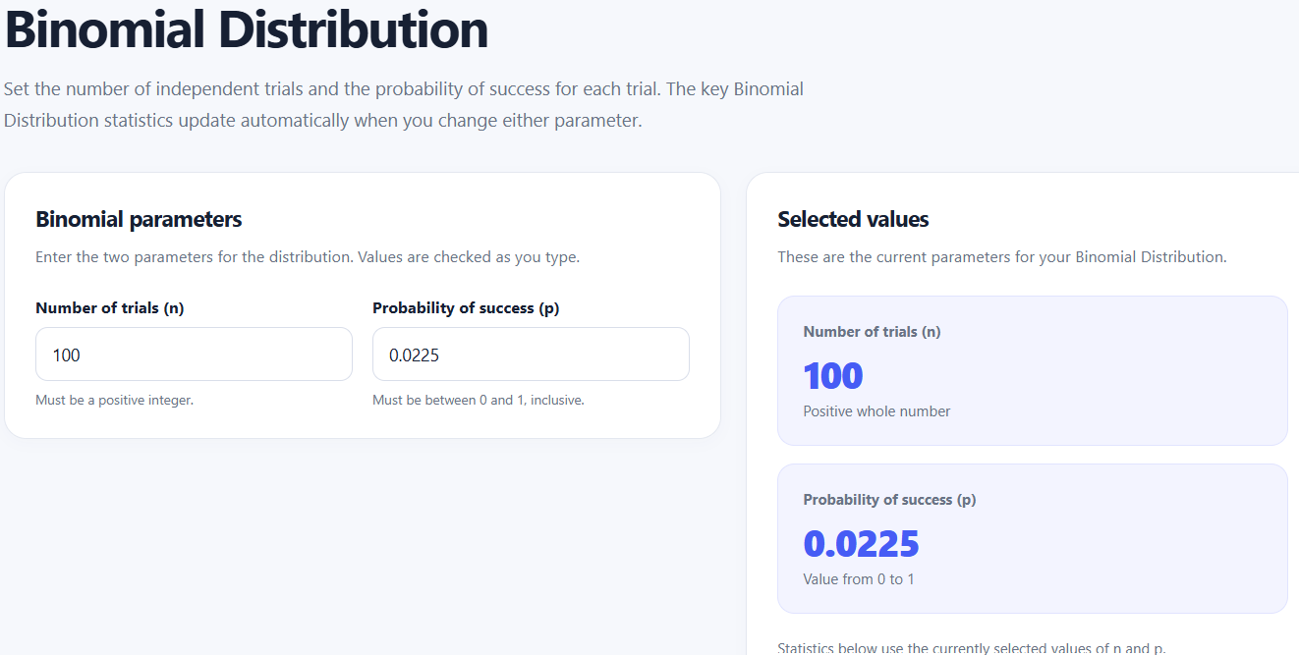
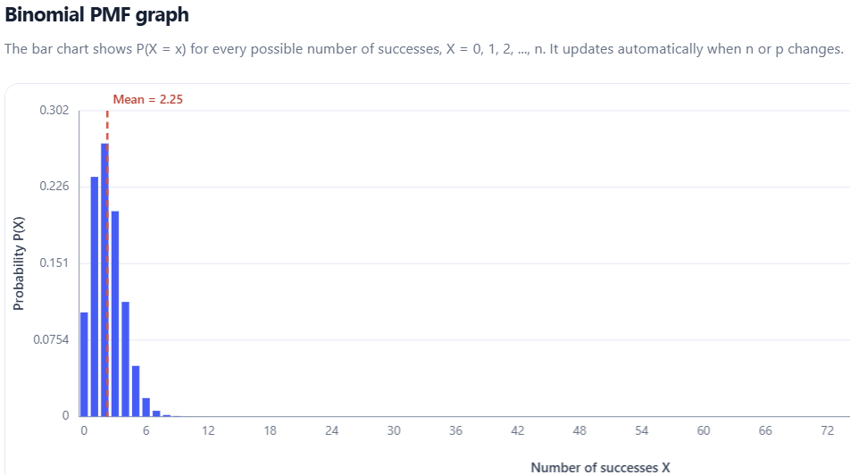

2

Exactly 3 failures = (k=3) PMF Graph (Mean(np) = 2.25)
Right-skewed distribution centered at a mean, with highest probabilities concentrated at k=1,2,3.

Ans: 3
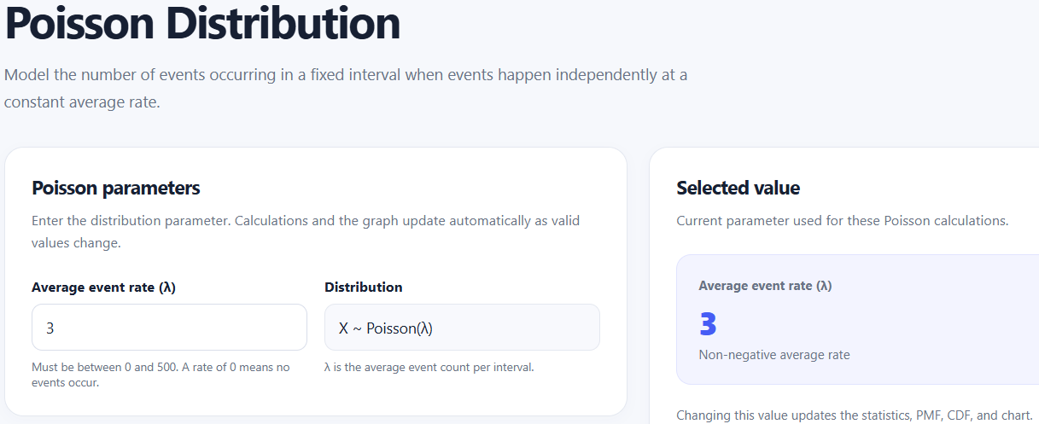
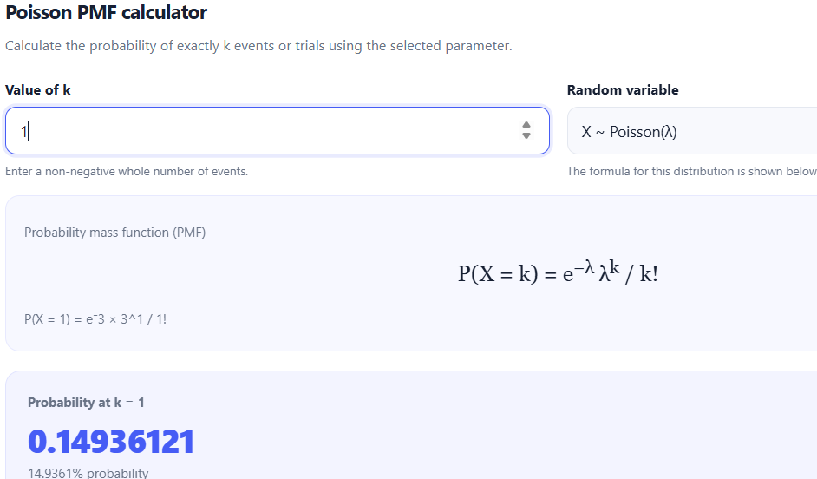
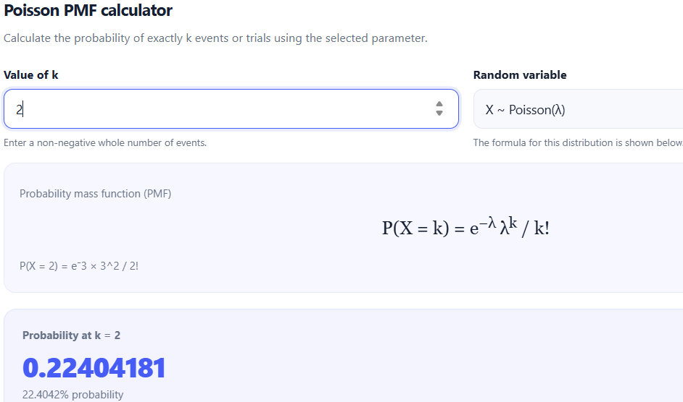
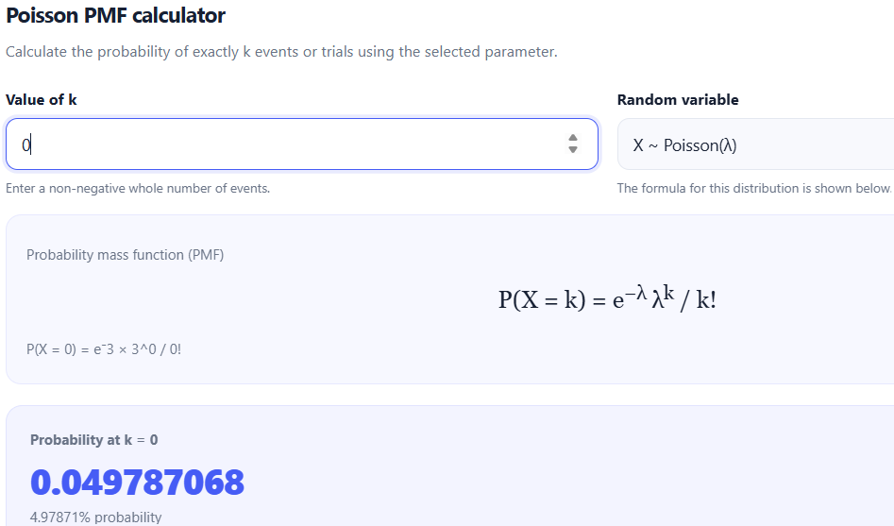
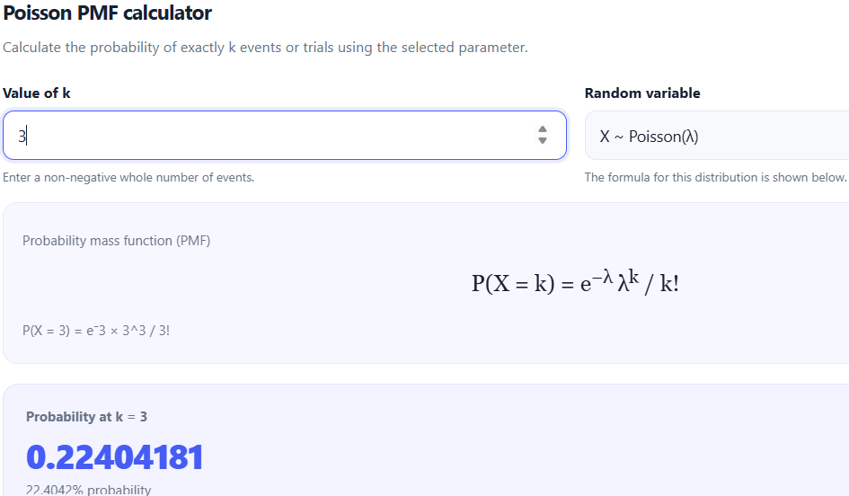

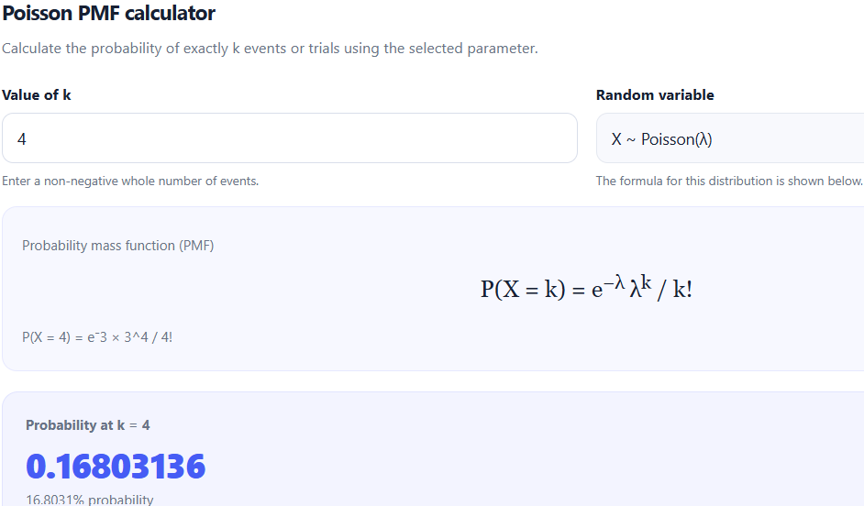

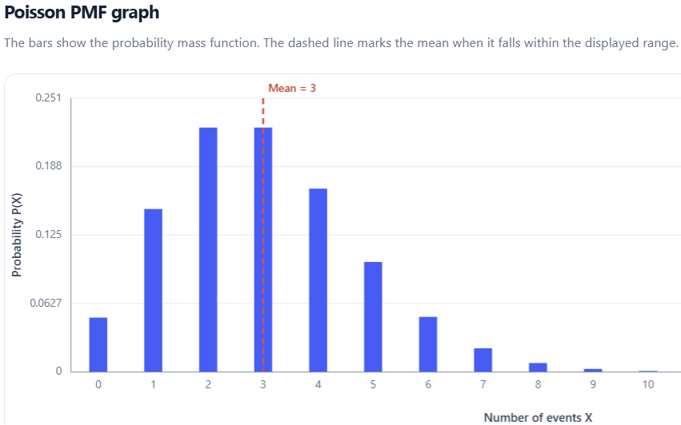

Increases from k=0 to k=2, where k=2 &3 have Bimodal peak and then decreases after k=3.
Ans 4: lambda=2 lambda=3
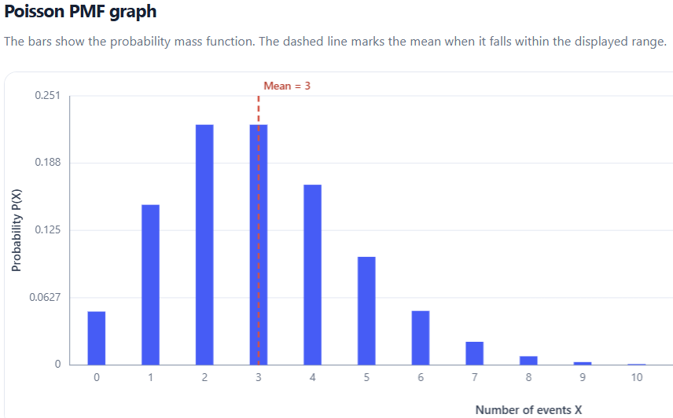
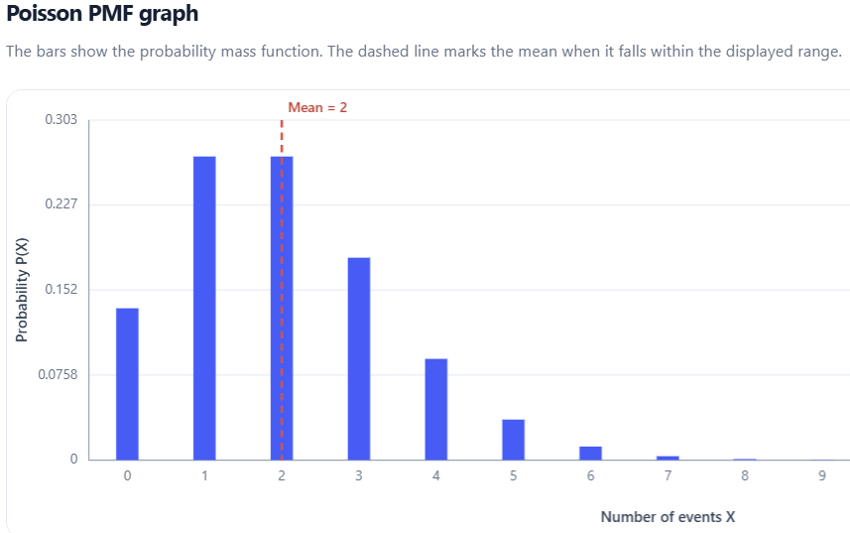
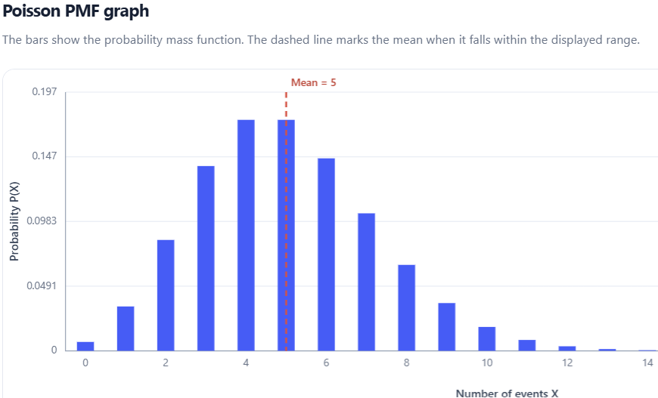
lambda=5
The alert rates (lambda) increases, the
Probability mass moves rightward,
The graph spreads wider.

Ans 5:
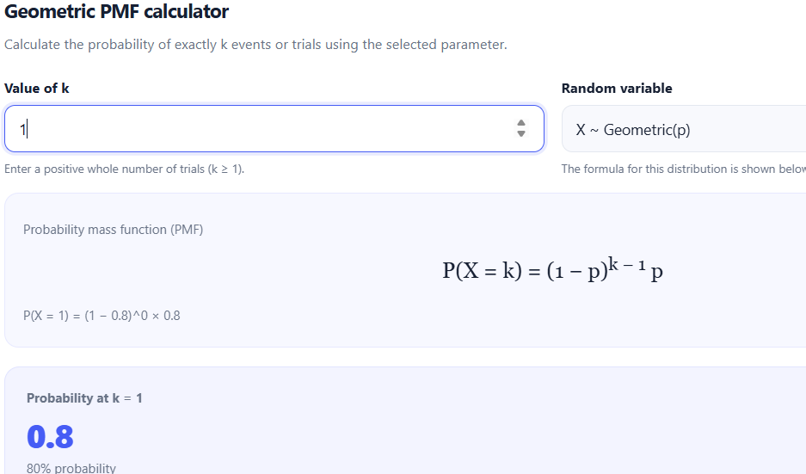
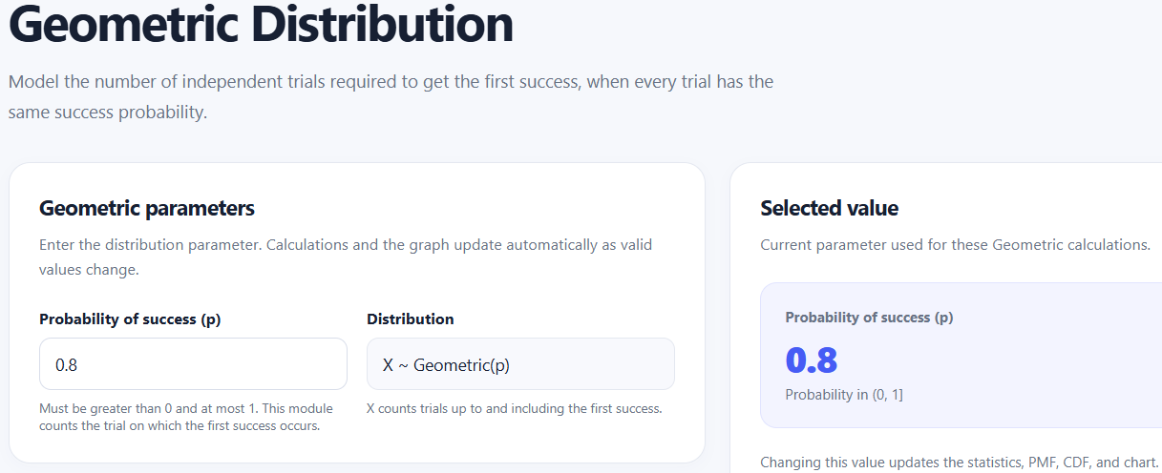
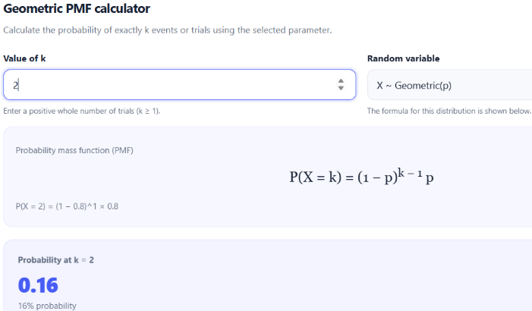

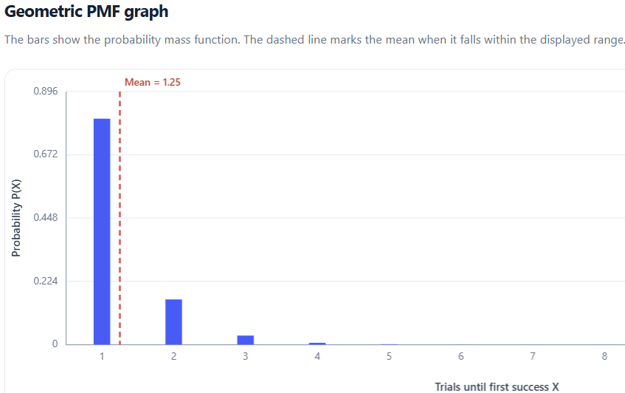
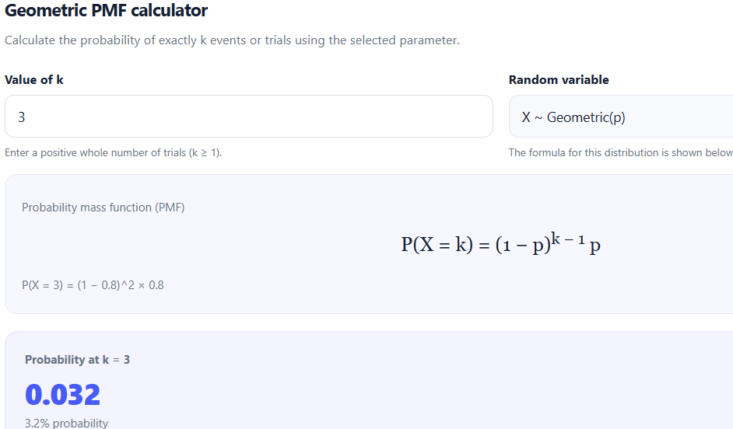

6

Probability decreases drastically as k value increases when p=0.8.

Ans 6:
​Monitoring Thresholds: A normal lambda = 3 rate produces >= 4 alerts roughly 35% of the time. Alert thresholds must be set above 6 or 7 to avoid alerting on normal operational noise.
​Investigating Failures: Because P(X <= 4) ~= 92% for the binomial setup (n=100, p=0.0225), observing 5 or more failures strongly indicates an active system regression rather than random variation.
​Retry Policies: With an 80% recovery probability per attempt, 99.2% of issues resolve within 3 tries. A retry limit of 2 to 3 attempts is optimal; higher limits waste resources on unrecoverable failures.

